Faculty Report - October 2017
TANZANIA LEADERSHIP CONFERENCE – Oct 2017
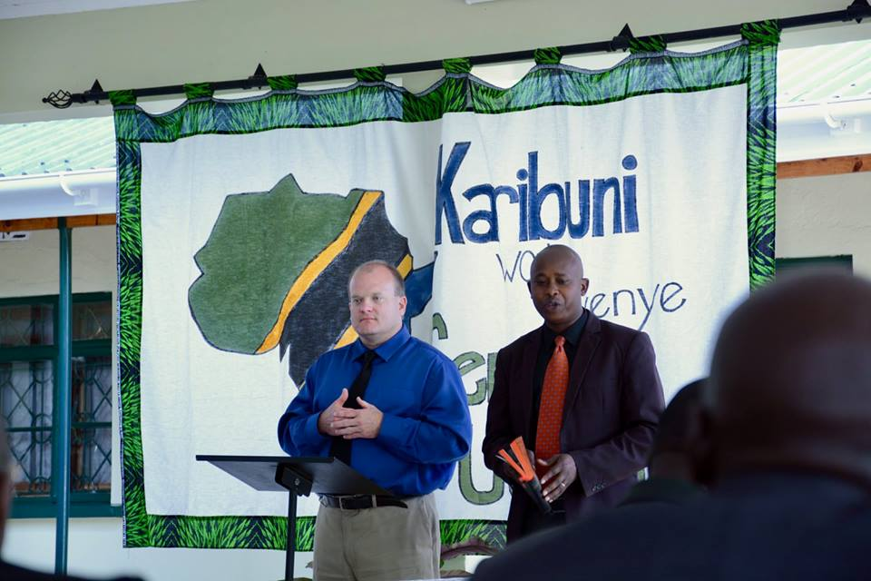
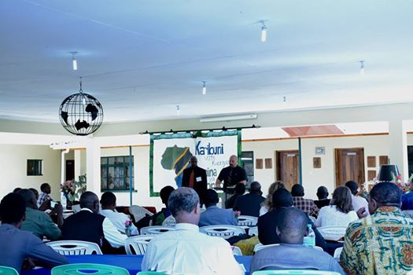

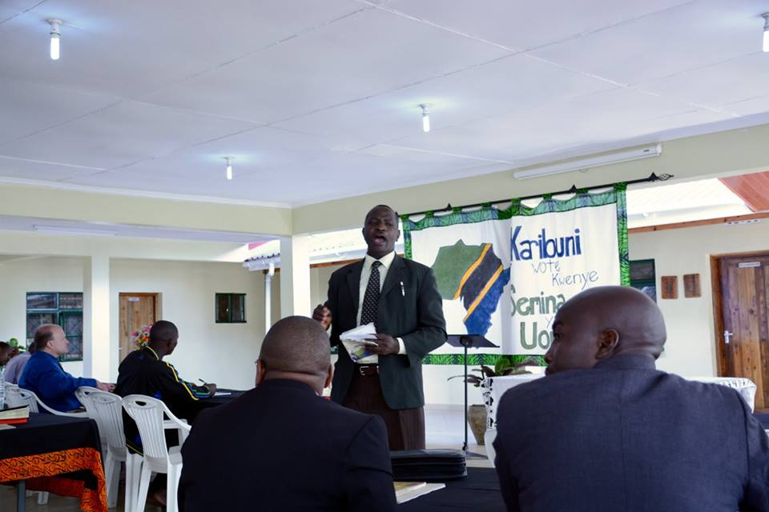

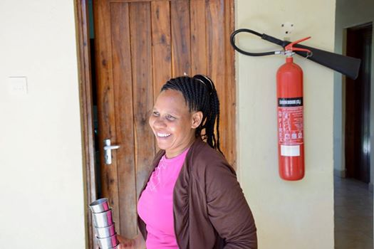

The Tanzania leadership conference this year was very successful we had 50 graduates of ACSOP who have attended compared to last year which we had only 34 Alumni in the meeting. We thank God Many good sermon from the book of I Corinthians, the theme this year was Church in Africa. Powerful lessons were presented by different speakers both local and from USA. We had over 200 participant this year and 15 speakers. It was another moment for the graduates to meet their fellow brother who preaches at different locations. Brothers from Elias Owana from Kenya and Uganda felt so very welcomed when they had chance to visit and preach to the nearby congregations where their fellow graduate are working.
During the conference the Alumni had had a time together to fellowship in meal and a cake. Our Brother Eliasi Owana, Tod Stocks and Brad Whinery from USA presented their speeches to encourage the graduate to work together to build the Kingdom of God In East Africa and beyond. The first and second year got an opportunity to serve their fellow graduate with dinner. As Alumni president, I had an opportunity to visit with some graduates and share their successes in their local ministry and I would like to share just in numbers.
- Five new congregations were planted this year .
- About 250 new souls were added by the Lord this year through house to house evangelism, Open air gospel meetings and seminars.
More of this report will come at the end of the year statistics.
Please what we are asking to you is only your prayer as we are teaching people to observe all things and continuing making Disciples of Christ and grow the Kingdom of God here in Arusha and East Africa beyond.
In Him,
Godfrey Mngoma
Dean of Students, Andrew Connally School of Preaching
A Bear Valley Bible Institute of Denver extension school
Arusha, Tanzania

